**Backup and restoration evidence**

We have start taking backup at 3:37PM.

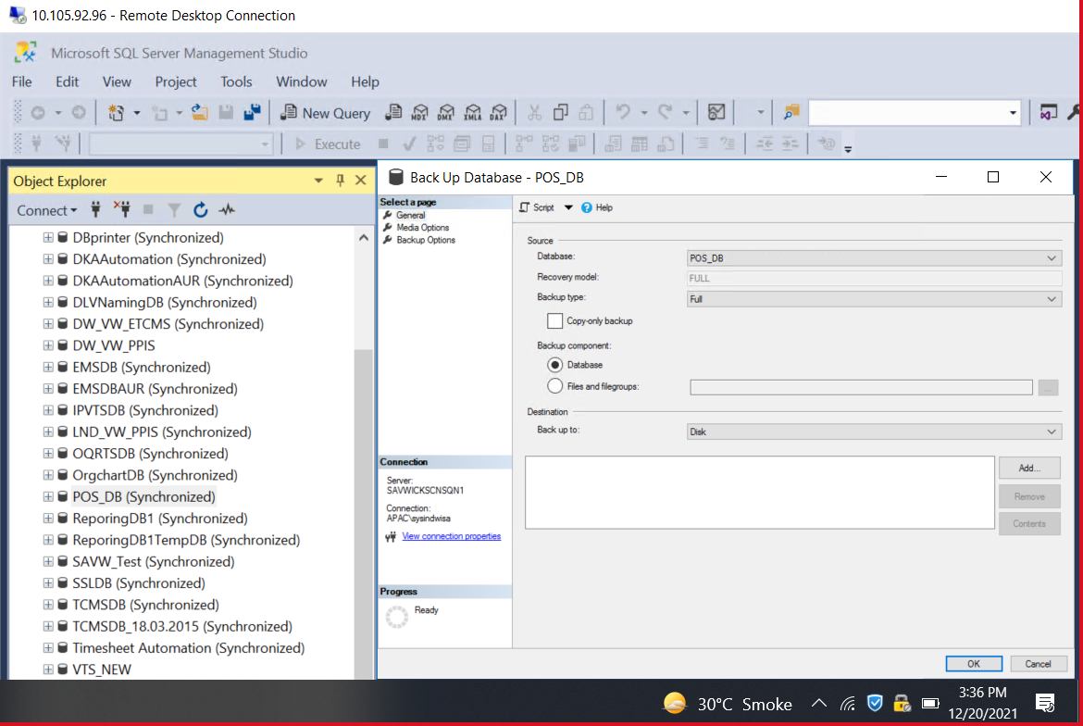

Backup Completed by 3:38 PM.

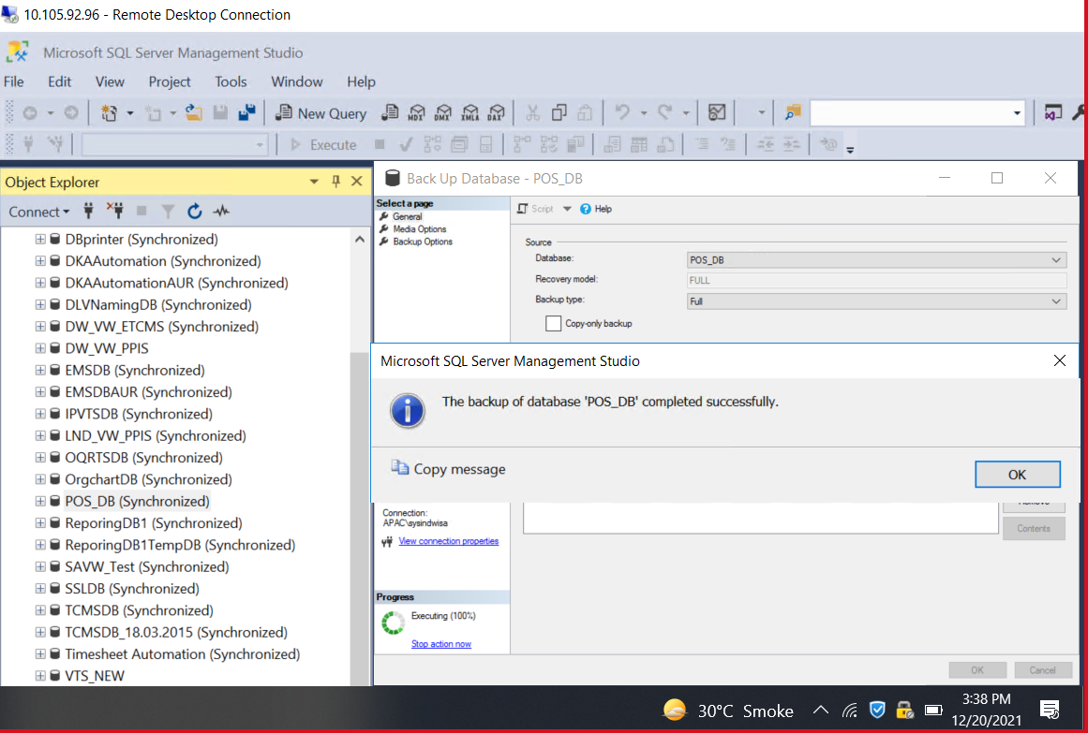

Selecting recent backup for restoration.

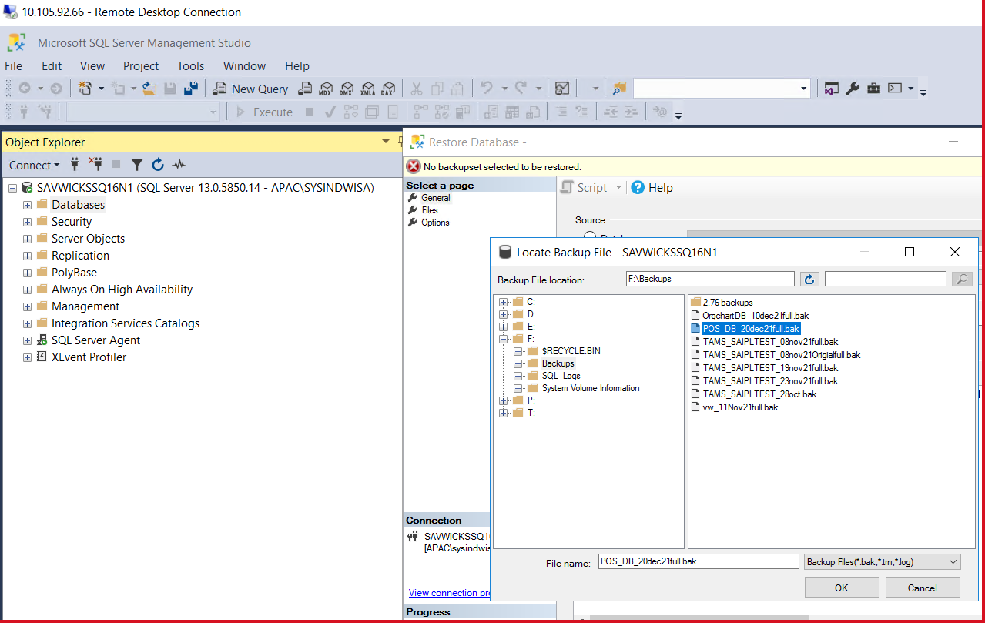

Executing the select backup and script at 3:41 PM

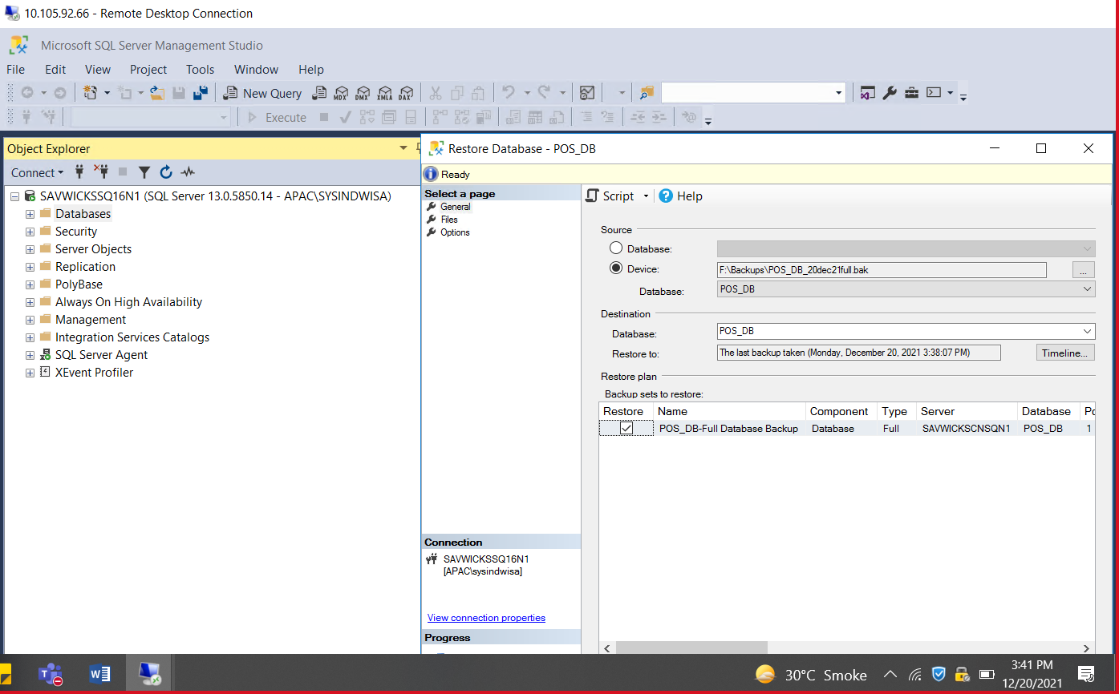

Database restored successfully at 3:42 PM.

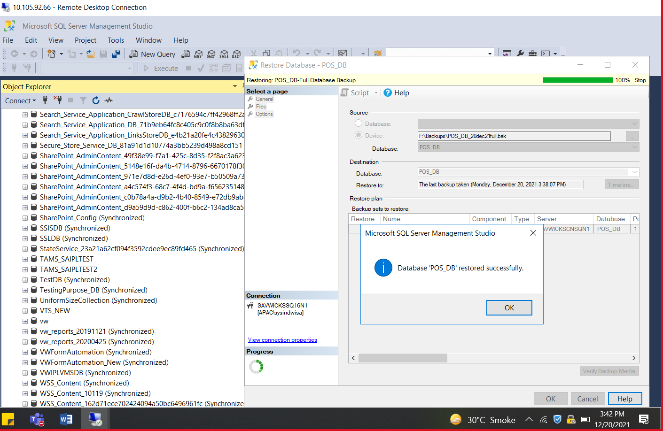

Screenshot of test server (10.105.92.69):

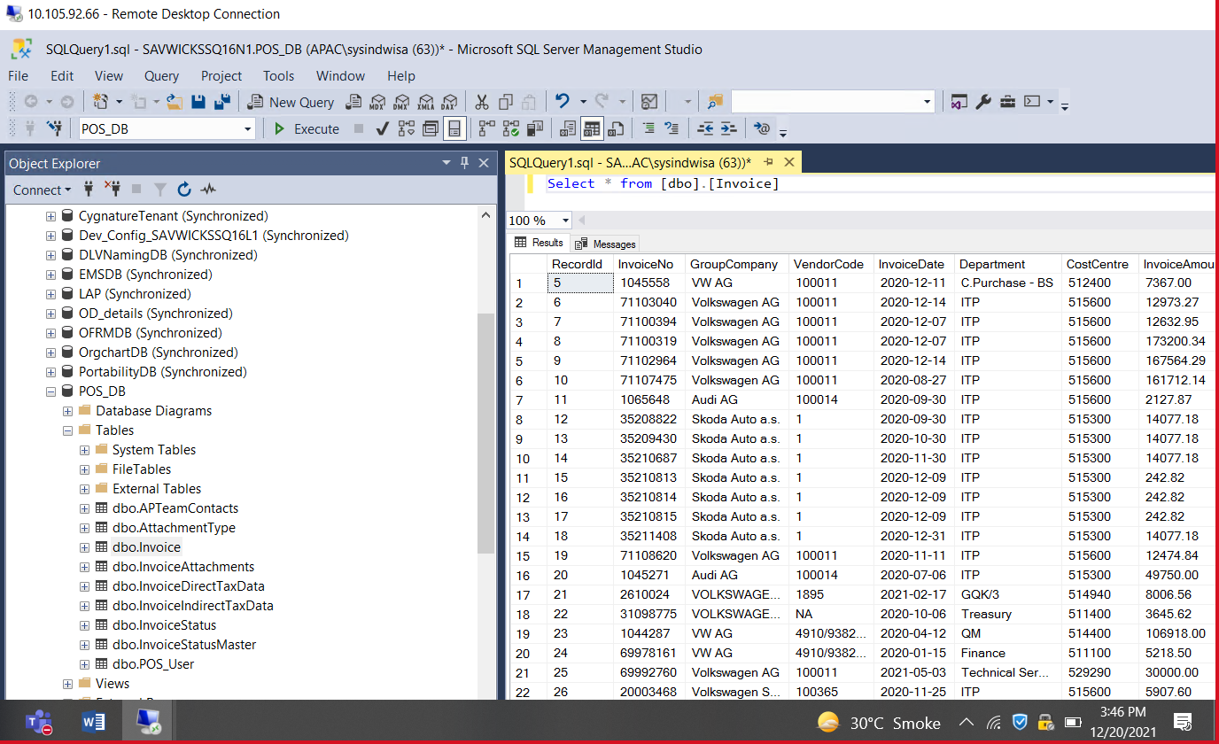

Screenshot of production server(10.105.92.99):

